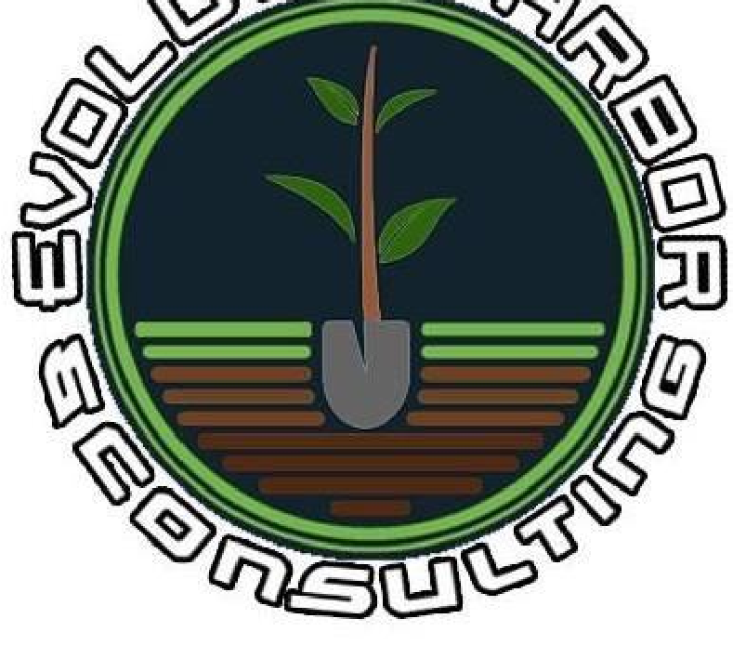

# **Arboricultural Impact Assessment Report**



Prepared for:

Prepared by: Mitchel Newbery

0405 687 433

Elizabeth Cowan

0423 870 742

Arboricultural Impact Assessment Report

# Overview

The purpose of this report is to identify the trees on the site and the surrounding sites, detail the current condition of the trees and how they may be affected, either directly or indirectly by proposed works, assess and consider the location of trees in regard to the proposed works and where applicable make recommendations for retention and protection or removal and replacement in accordance with AS4970 (2009) Protection of Trees on Development Sites.

Site documents indicating the subgrade services, sections, elevations, or landscaping were not referenced for the purpose of producing this report.

# Legislation

Where relevant this report has been produced with reference to:

* Parramatta DCP 2011 - as amended 13 Mar 2020
* Council’s list of significant trees
* AS4970 (2009) Protection of Trees on Development Sites
* AS4373 (2007) Pruning of Amenity Trees
* Biodiversity Conservation Act (2016)

# Disclaimer

Evolution Arbor and Consulting has taken care to ensure all information collated and reported in this publication has been obtained from reliable sources. All information covered in this report is based on the observations of the tree/trees examined at the time of the inspection. All information has been verified however Evolution Arbor and Consulting can neither guarantee nor be liable for the accuracy of information supplied by others.

This report is not intended as and does not represent any form of legal advice. Evolution Arbor and Consulting notes that laws, courts and governmental regulations in New South Wales and on federal level are subject to frequent change, and as such, Evolution Arbor and Consulting has made every effort to ensure the accuracy of the information included but cannot be held liable for any changes in relevant legislation or guidelines implemented after the publication of the report.

To the legalized extent, you agree that Evolution Arbor and Consulting is not liable to you or any other person or entity for any loss (including financial) or damage caused or alleged to have been caused (including loss or damage resulting from negligence), either directly or indirectly, by your use of the information made available to you in this report.

# Observations

## The Site

## Physical Description

* The site is level and rectangular in shape with a south-east facing aspect.

## Site Area

* The site is zoned R2: Low Density Residential

### Relevant LGA Site Information

* The formal site description is Lot 824 / Plan# DP36700

## Heritage and Significant Items:

* No Aboriginal or significant items were observed on the site on noted on the NSW Government ePlanner Spatial Viewer.

# Method

created a record of the health and condition of the trees on the site and surrounding sites. Only what was reasonably accessible was assessed, no penetrative or diagnostic tests were conducted, nor were any underground parts of these trees assessed. This was performed, by Mitchell Newbery and Elizabeth Cowan.

The Assessment consisted of a visual inspection of all trees from the ground. No aerial inspections were conducted at this time. This style of tree assessment has been adapted Matheny & Clark, 1994 and is recognized by most Arboricultural Associations, such as Arboriculture Australia, as industry standard. International Society of Arboriculture (ISA) refers to this style of assessment in their best management practices titled “Tree Risk Assessment”. The risk assessment matrix utilized by Evolution Arbor and Consulting is commonly used within our industry.

This risk assessment matrix is based upon the formula developed by Nelda P. Matheny & James R. Clark which is also recognized by ISA (International Society of Arboriculture). A hazard rating was implemented to assist in making recommendations regarding the above-mentioned tree/trees observations below. This hazard rating considers surrounding infrastructure beneath the abovementioned tree, this being a residential dwelling, private garden, public walkway and public road. The location of this tree and surrounding infrastructure would give this tree a “constant use” rating defined by Matheny & Clark, 1994. Industry standard considers an area of “constant use” as an area in frequent use such as a “busy area, main thoroughfare, street, parking lot, etc”.

Any heights and or distances referenced are approximations, no measuring tools analogue, digital or mechanical were used. All photos unless stated otherwise were taken by Evolution Arbor and Consulting personnel using mobile phone cameras. Local and State tree protection rules and legislation were considered during the preparation of this report.

It is common knowledge in NSW that Ring Barking, Topping, Lopping, Removing, injuring and/or wilful destruction of any tree/s is prohibited unless with written consent from the appropriate council.

# Observations

## Tree Identification

# Discussion

# Recommendations

## Tree Protection Measures

# Appendix 1 – Site Plan with Tree Protection Measures

# Appendix 2 – Images

# Appendix 3– Tree Inspection Form

# Appendix 4 – Glossary

|  |  |
| --- | --- |
| VTA | VTA or Visual Tree Assessment, industry standard for assessing trees. |
| Hazzard | A Hazzard is defined by Workcover NSW 1996 as anything with the potential to harm property, health and/or life. |
| DBH | DBH or Diameter at Breast Height is the industry standard of trunk measurement at 1.4 meters above ground level. |
| DAB | Diameter at base |
| Infrastructure | Hard stands such as roads, houses etc. that cannot be moved. |
| Vigour | The overall health of the tree and the ability to counter Physical strain/stress. |
| Asymmetry/Asymmetrical | Asymmetry is a clear difference in the two halves. |
| Target area | The area immediately beneath the tree that may be impacted in the event of failure. |
| Codominant | The term codominant is used to describe two (2) or more stems of equal size growing from the same location on the tree. |
| Deadwood | Dead branches within the trees canopy which can be quantitively considered as separate to the crown cover. |
| Die Back | The death of some areas of the crown. |
| Epicormic shoots | Juvenile shoots produced at branches or trunk from epicormic strands. |

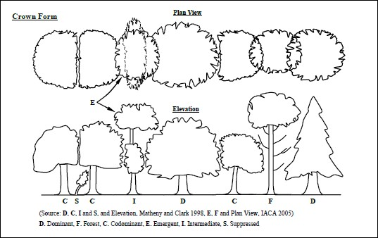

# Appendix 5 – Pruning Standards

Any and all pruning recommended in this report is to comply with Australian Standards, these standards can be found in AS- 4373-2007 Pruning of Amenity Trees. All works should be conducted in a manner so as to conform with NSW Work Cover Authority’s Code of Practice titled, Tree Work 2007.

All pruning works are to comply with the relevant Tree Management Policy, Tree Management Order or Tree Preservation Order where applicable, these guidelines can be found on an approved development application, approved consent for works letter or the local Council’s website. Depending on the consent sought for the site will determine which of these is applicable.

Tree maintenance and removal work is dangerous and as such should be conducted by Arborists who hold the relevant competencies and qualifications under the Australian Qualification Framework, with a minimum of three (3) years of continuous experience in carrying out these tasks, these professionals should also hold the relevant insurances to undertake these works.

# Appendix 6 – Guidelines for Tree Protection Works

Tree Management Plan – Prior to any works commencing within this site a project arborist should be appointed, to supervise any and all tree protection procedures stated in this report and/or stated in the approved development application. The project arborist should have the relevant qualifications set out in the Australian Qualification Framework.

Milestones – Milestones set out in this report are to be adhered to at the relevant times during the development, any and all relevant paperwork is to be to the relevant local authority.

Tree protection zones – Each required tree protection zone (TPZ) is to be incorporated into the relevant construction method. Protective fences are to be installed before works commence in the areas outlined in the Tree Protection Plan above. Under the Australian Standard for Protection of Trees on Development Sites, tree protection should be twelve (12) times trunk diameter measured at breast height (DBH), this means a tree with a one (1) meter DBH would require a tree protection zone of twelve (12) meters. This area can be altered to accommodate the proposed works; however, this can only be done by the project arborist appointed to the site and only be done where no other option is possible or feasible.

Ground Protection – Ground protection should be included within the TPZ at the time the protection is erected, this will enable the protection to be moved if temporarily removed if access is required within the TPZ. Ground protection should be in the form of good quality leaf mulch spread at a thickness of 100mm, with mulch spread at this depth it will remove the possibility of soil compaction and root damage. Leaf mulch also acts as a natural insulator which helps keep the roots at an optimal temperature whilst also releasing nutrients back into the soil during works. Whilst leaf mulch spread at a depth of 100mm over the top of a permeable material such as geo textile fabric is preferred, other options are possible such as crushed rock under rumble boards and other natural materials.

Excavation within a Tree Protection Zone – where excavation is required within a TPZ, the works should be done in the least invasive way possible, excavations should be conducted by hand under the supervision of the project arborist. Where it is not feasible to conduct excavations by hand due to an obstacle such as a steep slope, these works may be possible to be conducted by machine. If the works to be completed may jeopardize the structural integrity of the tree or the retainability of the tree, a reassessment should be conducted, and the retention value be revised and possible removal of the tree.

# Appendix 7 – Milestones

Tree protection prior to commencement of works – All tree protection is to be erected prior to the works commencing, this includes all fencing and ground cover for all retained trees and shrubbery. Tree protection signage that meets the specifications detailed in AS 4970-2009 Protection of Trees on Development Sites is to be installed on all required fences.

This is milestone one (1) the project arborist is to inspect all retained trees and shrubs at this point and complete the required documentation before works proceed. Demolition and removal of trees – At the commencement of works all required tree removals should be completed, this should be done a manner so as to not disturb any retained trees and/or shrubs.

After Demolition and before construction – Prior to commencement of construction works any required regrading around retained trees should be completed where possible, location of underground services within the TPZ of retained trees should also be completed at this time. Any relocatable buildings such as site sheds and toilets should be taken into consideration at this time, it is possible to store these buildings within the TPZ of a retained tree, providing no harmful chemicals or vehicle traffic is to occur.

This is milestone two (2) the project arborist is to reinspect any retained trees and shrubs prior to the commencement of construction works and assess tree protection measures installed as part of the D/A approval conditions, all required documentation is to be completed for the respective consent authority.

Tree protection during construction – All tree protection zones are to remain for the duration of works within the site, any woody roots found during excavation that must be pruned shall be done with a sharp tool so as to leave a clean cut, any required root pruning is to be done under the supervision of the project arborist. Any weeding that must be done within the TPZ of a retained tree is to be done by hand to create minimal disturbance around the root system of the retained trees, no poisons are to be used in the vicinity of any retained trees or shrubs.

Milestone three (3) the project arborist is to frequently inspect the retained trees and TPZ during the construction, any alterations to a TPZ required is to be done so by the project arborist, all relevant documentation is to be completed at each inspection and submitted to the respective consent authority.

Completion of construction works – At the completion of construction works all TPZ measures are to remain in place until the project arborist is able to inspect the condition of the trees, all resulting debris from construction is to be removed as well as any construction vehicles and temporary buildings removed prior to final inspection.

Milestone four (4) upon completion of works the project arborist is to complete a final inspection, at this time an assessment of all retained trees is to be completed and all relevant documentation completed. This documentation is to detail any remedial care required to ensure the longevity of retained trees. All relevant documentation is to be submitted to the respective consent authority

# Appendix 8 – Tree Significance Assessment Criteria

Per the IACA Significance of a Tree, Assessment Rating System (STARS):

1. High Significance in landscape
   * The tree is in good condition and food vigour
   * The tree has a form typical for the species
   * The tree is a remnant or is a planted locally indigenous specimen and/or is rare or uncommon in the local area or of botanical interest or of substantial age
   * The tree is listed as a Heritage Item, Threatened Species or part of an Endangered ecological community or listed on Councils significant Tree Register.
   * The tree is visually prominent and visible form a considerable distance when viewed from most directions within the landscape due to is size and scale and makes a position contribution to the local amenity
   * The tree supports social and cultural sentiments or spiritual associations, reflected by the broader population or community group or has commemorative values
   * The tree’s growth is unrestricted by above and below ground influences, supporting its ability to reach dimensions typical to the taxa in situ – tree is appropriate to the site conditions.
2. Medium Significance in landscape
   * The tree is in fair-good condition and good or low vigour
   * The tree has form typical or atypical of the species
   * The tree is a planted locally indigenous or a common species with its taxa commonly planted in the local area
   * The tree is not visible or is partly visible form surrounding properties as obstructed by other vegetation or buildings when viewed from the street
   * The tree provides a fair contribution to the visual character and amenity of the local area
   * The tree’s growth is moderately restricted by above or below ground influences, reducing its ability to reach dimensions typical for the taxa in situ.
3. Low Significance in landscape
   * The tree is in fair-poor condition and good or low vigour
   * The tree has form atypical of the species
   * The tree is not visible or is particularly visible from surrounding properties as obstructed by other vegetation or buildings
   * The tree provides minor contribution or has a negative impact on the visual character and amenity of the local area
   * The tree is a young specimen which may or may not have reached dimension to be protected by local Tree Preservation orders or similar protection mechanisms and can be easily replaced by a suitable specimen.
   * The tree’s growth is severely restricted by above or below ground influences, unlikely to reach dimension typical of the taxa in situ – tree is appropriate to the site conditions
   * The tree is listed as exempt under the provisions of the local Council Tree Preservation Order or similar protection mechanisms
   * The tree has a wound or a defect that has potential to become structurally unsound

Environmental Pest / Noxious Weed Species

* + The tree is an Environment Pest Species due to its invasiveness or poisonous / allergenic properties
  + The tree is declared an anxious weed by legislation Hazardous/Irreversible Decline
  + The tree is structurally unsound and/or unstable and is considered potentially dangerous
  + The tree is dead, or is in irreversible decline, or has the potential to fail or collapse in full or part in the immediate to short term.

The tree is to have a minimum of three (3) criteria in a category to be classified in that group

Note: The assessment criteria are for individual trees only, however, can be applied to a monocultural stand in its entirety e.g. hedge.

# Appendix 9 – Tree Retention Value

